Quarantined/Isolated Consumer in the Home

If a consumer is Quarantined/Isolated to a designated area (Bedroom) for possible exposure, displaying signs of illness listed on screening tool, has been given a positive test result or ordered by physician.

Set up an area outside the room for PPE equipment and trash can with lid. Hang signs on the door as a reminder to Wash Hands and use PPE before entering. PPE includes gloves, goggles, gown and mask. Toss contaminated PPE items in trash outside the door and wash hands immediately. Disinfect goggles and face shields with bleach solution and wash hands, hand sanitizer can be used if soap is not available.

* Set up a private area (bedroom) with doors closed and keep household members in another room. Move any roommates into another room and contact their guardian to inform them of the changes being made. You do not want to jeopardize either consumers HIPPA rights, so be sure not to use other consumer’s names, and or give any medical information.
* Stock the room up with needed supplies, B/P cuff, thermometer, any medical supplies, bedding, disinfecting supplies etc.
* To limit the chance of exposure designate one staff per shift to provide care to the at risk consumer.
* Clean/disinfect rooms daily.
* Limit movement throughout the home when possible, offer the infected person a mask when you are in contact with them.
* Use a separate bathroom if possible, toileting chairs can be use in the individual’s room. All areas of contact and any equipment used will need to be disinfected.
* If a positive Covid-19 case occurs in the home all consumers should be encouraged to wear a mask when out of their isolation area.
* Avoid sharing any household items (plates, cups and utensils) with infected person.
* Place dirty laundry and bedding in a trash bag and wash thoroughly, do not cross contaminate by washing with any other laundry. Immediately remove and wash any laundry that has any body fluids on them.

Staff need to avoid touching your eyes, nose, and mouth. Wash your hands after any contact.

See information on use of PPE and disposal of PPE:

* Due to current shortages in supplies, staff are encouraged use 1 mask per shift unless soiled. If removing mask during your shift, fold your mask in ½ leave the contaminated area on the outside and place in a paper sack with your name in it. Be sure when removing the mask from the bag that you avoid touching the outside of the mask. If exposure occurs wash hands thoroughly. Inspect the mask for rips, tears, or other damage each time you are putting the mask on. Replace if soiled, damaged, wet or deformed.
* IF using a cotton made mask, wash mask daily with laundry soap and dry on high.
* Home in Isolation/Quarantine
* -Set up a PPE station outside the home with a trash can with lid.
* -Place signs on the door as a reminder to use PPE equipment before entering the home.
* -Remove PPE equipment at the end of your shift outside to the home and dispose of in trash can. Use hand sanitizer to wash your hands so you do not re-enter the home unprotected.
* -Encourage consumers to remain in their rooms as much as possible and they chose to leave their rooms they should wear a facemask if they will, wash hands and perform social distancing. (6ft)
* -Eat in smaller groups for proper distancing
* -Avoid contact with people in the community practicing social distancing at work and outside of work.
* -Cover coughs and sneezes
* -Wash your hands frequently (even with gloves on)
* -Avoid sharing household items including towels, dishes and utensils
* -Keep areas clean and disinfected and wash your hands after disinfecting
* -Monitor yourself along with consumer for signs of possible infection. At the stage of Quarantine, staff per shift should document check off sheet information when they arrive at work and after their shift is over (2 times daily) consumer’s vitals should be taken and documented for each shift days, afternoons, and midnights.
* -Staff should remain at the home and not go into the community Re: stores for supplies or food. Use delivery services or other Listening Ear staff to deliver to the door. All supplies delivered will be found by the front door outside of the home for incoming staff. Confirmation of supplies will be checked over the phone. The purchaser can sign the receipt prior to leaving the groceries.
* Notify a health care provider if anyone is isolation develops any symptoms.
* **All staff shall follow the CDC, CMH, and Health Department Guidelines.**
* **Any positive test report should be reported to Listening Ear supervisor, CMH, consumers Guardian.**

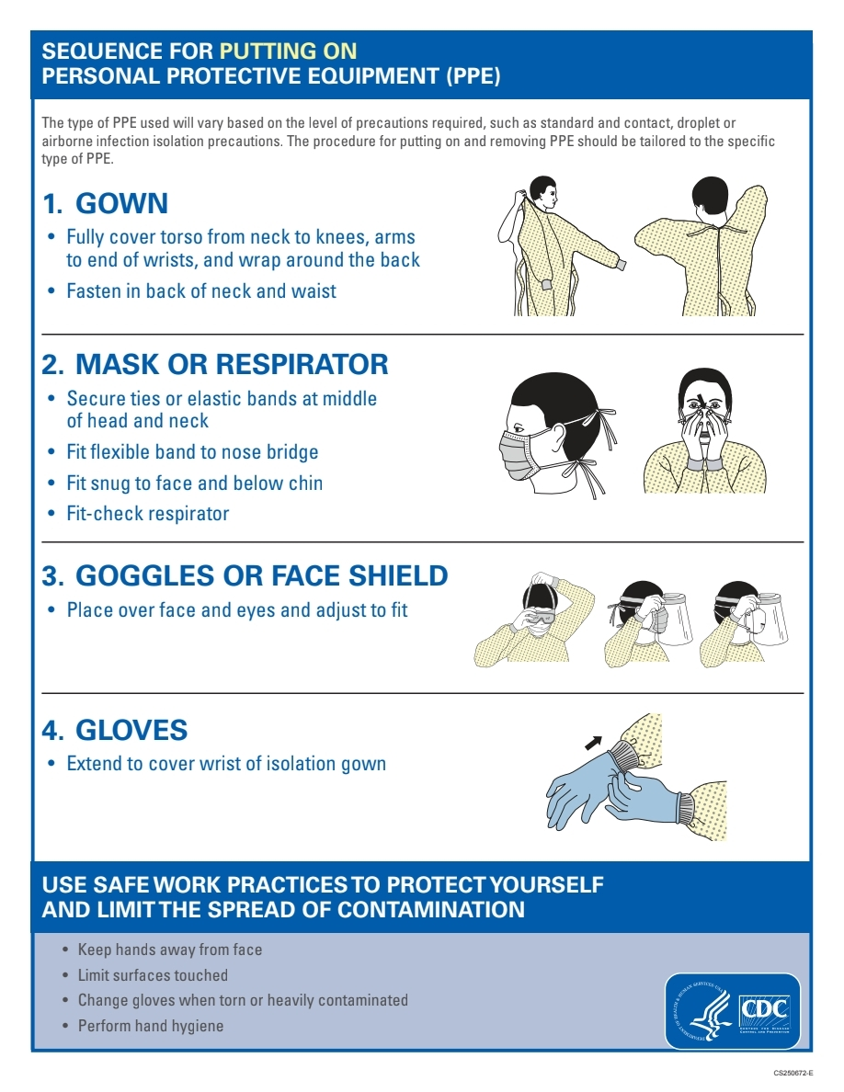

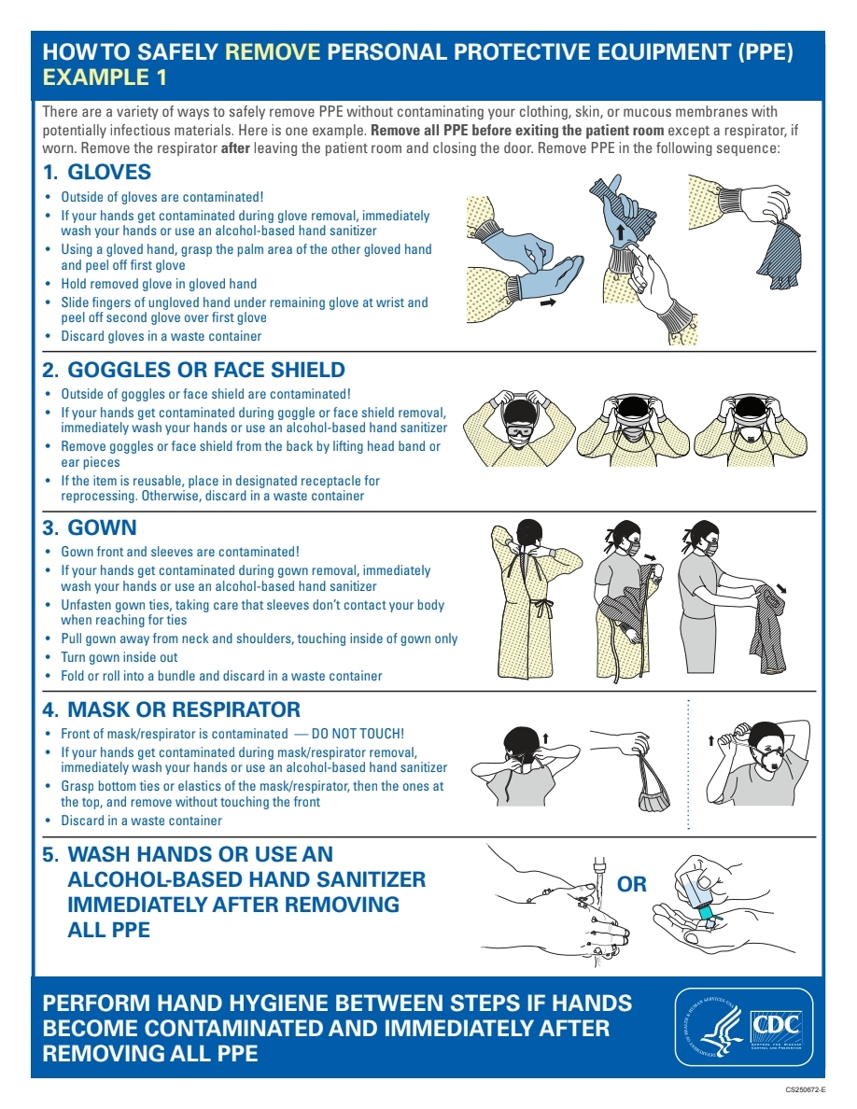

**How to clean and disinfect**

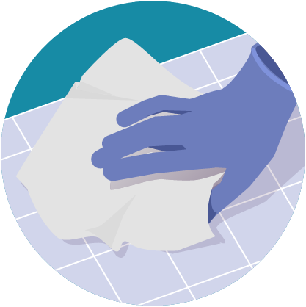

**alert icon Wear disposable gloves** to clean and disinfect.

**Clean**

* **Clean surfaces using soap and water.** Practice routine cleaning of frequently touched surfaces.

**High touch surfaces include:**  
Tables, doorknobs, light switches, countertops, handles, desks, phones, keyboards, toilets, faucets, sinks, etc.

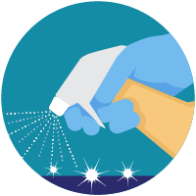

**Disinfect**

* Clean the area or item with soap and water or another detergent if it is dirty. Then, use disinfectant.
* **Recommend use of**[**EPA-registered household disinfectant**external icon](https://www.epa.gov/pesticide-registration/list-n-disinfectants-use-against-sars-cov-2)**.**  
  **Follow the instructions on the label** to ensure safe and effective use of the product.  
  Many products recommend:
  + Keeping surface wet for a period of time (see product label)
  + Precautions such as wearing gloves and making sure you have good ventilation during use of the product.
* **Diluted household bleach solutions may also be used** if appropriate for the surface. Check to ensure the product is not past its expiration date. Unexpired household bleach will be effective against coronaviruses when properly diluted.  
  **Follow manufacturer’s instructions** for application and proper ventilation. Never mix household bleach with ammonia or any other cleanser.  
  **Leave solution** on the surface for **at least 1 minute**  
  **To make a bleach solution**, mix:
  + 5 tablespoons (1/3rd cup) bleach per gallon of water

OR

* + 4 teaspoons bleach per quart of water
* **Alcohol solutions with at least 70% alcohol.**

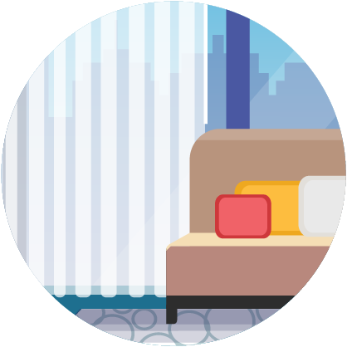

**Soft surfaces**

For soft surfaces such as **carpeted floor, rugs, and drapes**

* **Clean the surface using soap and water** or with cleaners appropriate for use on these surfaces.
* **Launder items** (if possible) according to the manufacturer’s instructions.Use the warmest appropriate water setting and dry items completely.

OR

* **Disinfect with an EPA-registered household disinfectant.** [These disinfectantsexternal icon](https://www.epa.gov/pesticide-registration/list-n-disinfectants-use-against-sars-cov-2) meet EPA’s criteria for use against COVID-19.

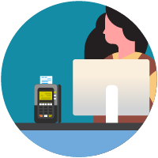

**Electronics**

For electronics, such as **tablets, touch screens, keyboards, remote controls, and ATM machines**

* Consider putting a **wipeable cover** on electronics.
* **Follow manufacturer’s instruction** for cleaning and dinfecting.
  + If no guidance, **use alcohol-based wipes or sprays containing at least 70% alcohol**. Dry surface thoroughly.

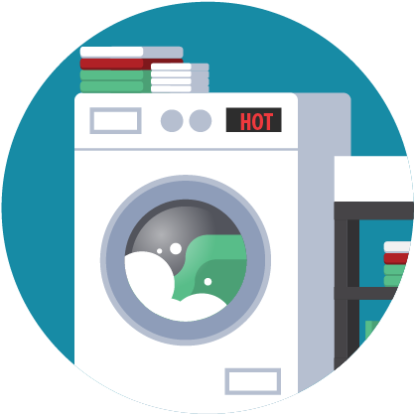

**Laundry**

For clothing, towels, linens and other items

* **Wear disposable gloves.**
* **Wash hands with soap and water** as soon as you remove the gloves.
* **Do not shake** dirty laundry.
* Launder items according to the manufacturer’s instructions. Use the **warmest appropriate water setting** and dry items completely.
* Dirty laundry from a sick person **can be washed with other people’s items**.
* Clean and **disinfect clothes hampers** according to guidance above for surfaces.

**Cleaning and disinfecting your building or facility if someone is sick**

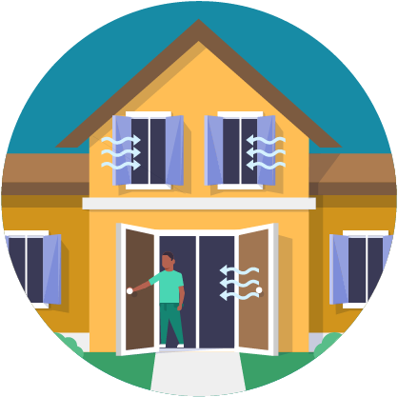

* **Close off areas** used by the sick person.
* **Open outside doors and windows** to increase air circulation in the area. **Wait 24 hours** before you clean or disinfect. If 24 hours is not feasible, wait as long as possible.

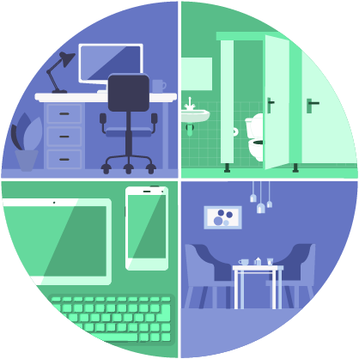

* Clean and disinfect **all areas used by the sick person**, such as offices, bathrooms, common areas, shared electronic equipment like tablets, touch screens, keyboards, remote controls, and ATM machines.
* If **more than 7 days** since the sick person visited or used the facility, additional cleaning and disinfection is not necessary.
  + Continue routing cleaning and disinfection.

**When Cleaning**

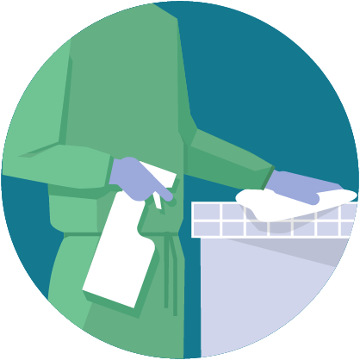

* **Wear disposable gloves and gowns for all tasks in the cleaning process, including handling trash**.
  + Additional personal protective equipment (PPE) might be required based on the cleaning/disinfectant products being used and whether there is a risk of splash.
  + Gloves and gowns should be removed carefully to avoid contamination of the wearer and the surrounding area.
* **Wash your hands often** with soap and water for 20 seconds.
  + Always wash immediately after removing gloves and after contact with a sick person.
  + Hand sanitizer: If soap and water are not available and hands are not visibly dirty, an alcohol-based hand sanitizer that contains at least 60% alcohol may be used. However, if hands are visibly dirty, always wash hands with soap and water.
* **Additional key times to wash hands** include:
  + After blowing one’s nose, coughing, or sneezing.
  + After using the restroom.
  + Before eating or preparing food.
  + After contact with animals or pets.
  + Before and after providing routine care for another person who needs assistance (e.g., a child).

**EMPLOYEE PROTOCOL FOR COVID-19 SCREENING**

If an employee has answered “Yes” to any of the questions on the attached Covid-19 screening tool the following procedures should be followed:

* If staff have any of the following symptoms they should not be allowed to work and should consult a doctor.
  + respiratory infection
  + dry cough
  + sore throat
  + fever
* Other symptoms to look for could include but would not prohibit staff from working:
  + nausea
  + vomiting
  + fatigue
  + new rash
  + myalgia (body aches)
  + headache
  + diarrhea
  + shortness of breath and
  + confusion or new cognitive symptoms
* Employee should be sent home and encouraged to call a health care provider and if possible retain a medical note stating the instructions the employee should follow. Whether quarantined, self-quarantined, or may return to work.
* If employee has answered “Yes” to the Domestic travel staff should provide more information as to the specifics of this travel (i.e. where traveled to, in contact with anyone testing positive for Covid-19, if in contact with someone that has been quarantined).
* Employee must contact Supervisor or DRS immediately
* Staff should take all necessary precautions to not spread this virus

If an employee has been put off work and tested for Covid-19 staff should do deep cleaning in the home making sure to disinfect surfaces, door handles, light switches, phones, bed rails office equipment, etc.. Staff should also continue to check their temp and watch for any other symptoms of Covid-19.

Staff should monitor all vitals for all consumers living in the home closely and document any changes and any of the following symptoms.

* + respiratory infection
  + dry cough
  + sore throat
  + fever
  + nausea
  + vomiting
  + fatigue
  + new rash
  + myalgia (body aches)
  + headache
  + diarrhea
  + shortness of breath and
  + confusion or new cognitive symptoms

**Ways to prevent spreading & general precautions of COVID-19.**

Including but not limited to:

- Frequent hand washing,

- Do not touch face, mouth, eyes or nose,

- Respiratory etiquette,

- Cleaning of surfaces,

- monitoring one’s temperature and health

- Not coming to the building if ill.

-May wear goggles or face shield if you cannot maintain 3 feet of separation.

Hand Sanitizer and Cleaning/disinfecting supplies will be available upon entry at the worksite for employees. Hand sanitizer will be available for employees in each office.

Clean and disinfect vehicles after use

Listening Ear will continue to consult and follow all guidelines as presented by the Health Department, CDC and CMH.

|  |  |
| --- | --- |
| General Instructions for Putting on an N95 Respirator (Mask) These instructions must be followed each time the N95 mask is worn. | |
| 1 | Before accessing and putting on an N95 mask  clean your hands.  *If wearing glasses, remove prior to putting on mask* |
| 2 | Cup the mask in your hand with the metal nosepiece at your fingertips.  Allow the elastic headbands (straps) to hang freely below your hand. |
| 3 | Position the mask under your chin with the nosepiece up.  Pull the top strap over your head resting it high at the top back of your head.  Pull the bottom strap over your head and place it around the neck below the ears |
| 4 | Using **both** hands, mold the nose area to the shape of your nose by pushing inward while moving your fingertips down both sides of the nosepiece. |
| 5 | **SEAL CHECK.** The mask seal MUST be checked before each use. To check the fit, place both hands over the mask and exhale. If air leaks around your nose, adjust the nosepieces as described in step 4. If air leaks at the mask edges, adjust the straps back along the sides of your head. Check again.  **If you cannot achieve proper fit, DO NOT enter the isolation room. Check with the nursing staff.**  *If wearing glasses, put them on* |

|  |  |
| --- | --- |
| General Instructions for Taking off an N95 Respirator (Mask) These instructions must be followed each time the N95 mask is taken off. | |
| 1 | Before taking off an N95 mask  clean your hands.  *If wearing glasses, remove prior to taking off mask.* |
| 2 | Bend forward slightly and carefully remove the mask from your face by touching only the elastic headbands (straps)  Without touching mask, pull bottom strap over head. |
| 3 | Without touching mask, pull top strap over head. |
| 4 | Throw mask into the garbage by holding it by the straps only.  *If wearing glasses, put them on* |
| 5 | Clean your hands. |